Broadway On Demand Purchase + Viewing Instructions for an On Demand Event

PURCHASING YOUR STREAM

STEP 1: Locate the production you want to purchase
Click [this link] to be taken directly to the event show page. It should look something like the photo below.
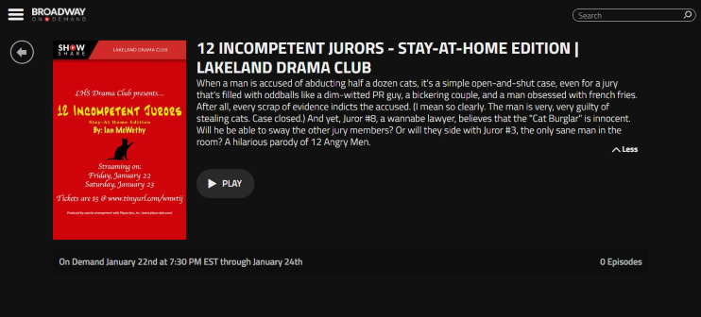

STEP 2: Click PLAY to be taken to the payment page

STEP 3: Log in /Create an Account
If you haven’t done so already, you will be prompted to either log in or create an account. If you are already logged in to you BOD account you will be taken directly to the payment page.

- If you already have a Broadway On Demand account:

Enter your email and password and click Submit.

- If you don’t already have a Broadway On Demand account:

Select Click here to Sign Up.
You will be asked to enter an email and password and click Submit.
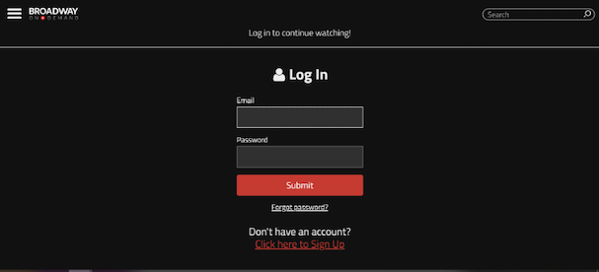

STEP 4: Pay for Your Stream

Once you’ve logged in or created your account, you will be automatically taken to the payment page. Here you can pay for the stream with a credit card or PayPal.

If you’ve been given a Promo code (sometimes referred to as “Comp code” or “Access Code”), enter the code into the “Add Promo Code” field and click Apply.

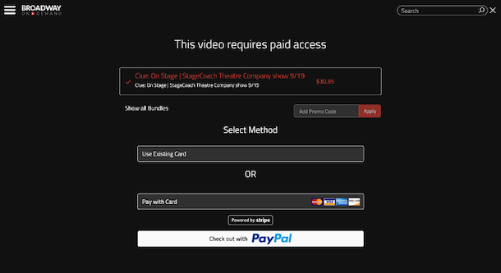

Confirm your purchase to complete the transaction.

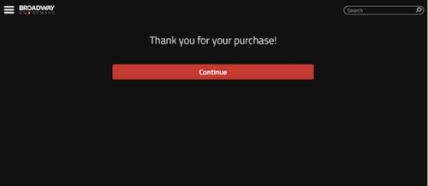

Congratulations! You’ve completed your purchase and now are ready for the show!

Still have questions? Click here for a helpful video tutorial.

WATCHING YOUR STREAM
STEP 1: Navigate to the Production Show Page
Click [this link] to be taken directly to the event show page.
Hint: this is the same link you clicked to purchase the event

STEP 2: When the event becomes available, click PLAY
Hint: If you haven’t done so already, you will be prompted to log in to your account.

STEP 3: Enjoy the show
You will be able to pause, rewind, and rewatch the video as many times as you'd like during the viewing period.

Enjoy the show!

CUSTOMER SERVICE INFO
If you experience any difficulties trying to access the production, please email info@broadwayondemand.com. BOD has staff working that email 24/7 and they have a 24-hour response time. You can also call (332) 255-4180 Monday-Friday 9AM-5PM Eastern Standard Time (US holidays excepted).

